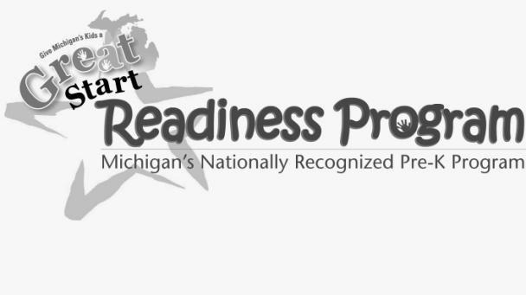 ***Redford Union Schools***

 **We are now accepting applications for our**

**C:\Users\Nedeau\AppData\Local\Microsoft\Windows\Temporary Internet Files\Content.IE5\C42VB77C\MC900232149[1].wmf2015-2016**

**Pre Kindergarten program!**

* Redford Union residents may apply.
* ***Free*** State/Title 1 funded part time *preschool* program.
* AM or PM classes are Monday-Thursday.
* A short interview will determine if your family qualifies.
* Children must be 4 years old ***on/ before*** September 1, 2015.

**Accurate 2014 family income information will be needed at time of interview.**

**4 STAR State Approved Quality Program.**

**NUTRITIOUS**

**MEALS**

**LEARNING**

**THROUGH PLAY**

C:\Users\Nedeau\AppData\Local\Microsoft\Windows\Temporary Internet Files\Content.IE5\MRYXB7DH\MC900232910[1].wmf

**EMPHASIS ON**

**READING & MATH**

**WRITING**

**DAILY**

**ROUTINE**

**EMPHASIS ON SELF-HELP SKILLS**

C:\Users\Nedeau\AppData\Local\Microsoft\Windows\Temporary Internet Files\Content.IE5\KL5VFS7J\MC900232107[1].wmf

**MCj03537100000[1]MacGowan School**

**MCj03537100000[1]CALL: 313-242-3800**

*Transportation is available.*